Experiment 7: Video Processing in Slow and Fast Motion
Aim: To read and display a video using Python and demonstrate slow-motion and fast-motion playback.
Procedure:
- Import the OpenCV library.
- Open the input video file.
- Read and display the video frames.
- Display the frames with different delays to demonstrate slow and fast playback.
- Release the video resource and close the windows.
Program:
import cv2
cap = cv2.VideoCapture(r"D:\Amrita\Downloads\sample_video.mp4")
while True:
ret, frame = cap.read()
if not ret:
break
cv2.imshow("Slow Motion", frame)
if cv2.waitKey(100) & 0xFF == ord('q'):
break
cap.release()
cv2.destroyAllWindows()
cap = cv2.VideoCapture(r"D:\Amrita\Downloads\sample_video.mp4")
while True:
ret, frame = cap.read()
if not ret:
break
cv2.imshow("Fast Motion", frame)
if cv2.waitKey(1) & 0xFF == ord('q'):
break
cap.release()
cv2.destroyAllWindows()
Input:
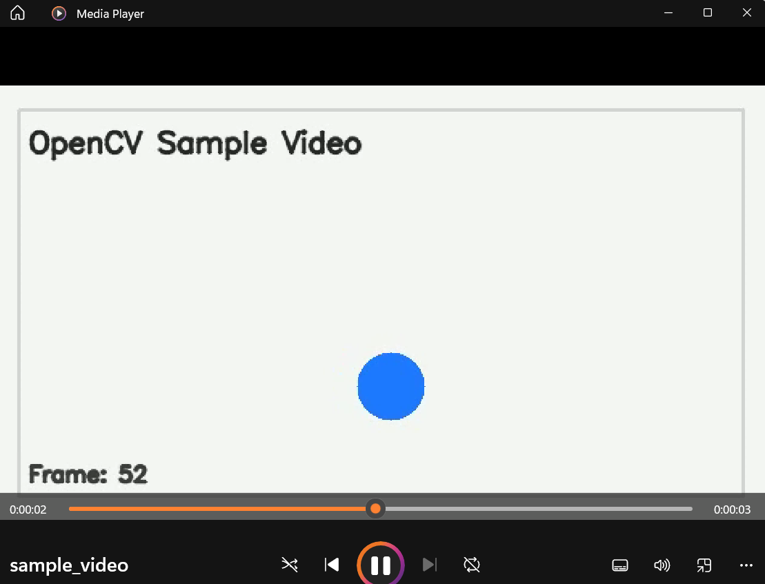
Output:
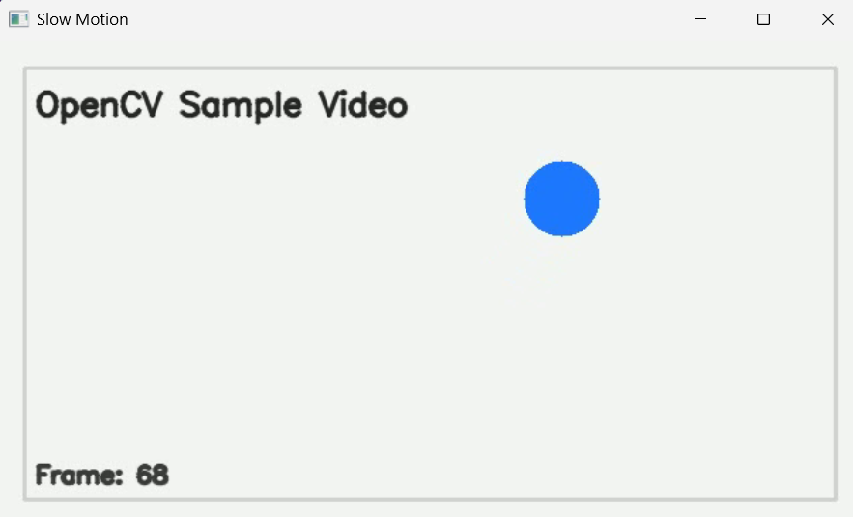
Result:
The input video was successfully displayed in slow motion and fast motion using different frame delays. Press q to stop each playback.

